Myles J Sartor
Matthew Griffin
STAT100-0121
27 November 2023
Problem Set 8
1a. 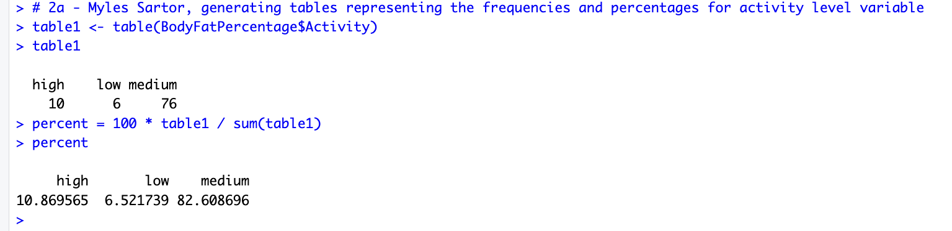
(Same image as Problem Set 7 2a. question).
1b.
Null Hypothesis:
H₀ : p = .16
Alternative Hypothesis:
H₁ : p < .16
This is the alternative hypothesis I wrote to test the claim that less than 16 % of all adolescent girls have a “high” activity level.
1c. np (1 – p) >= 10
^ 92 * .16 (1 – .16) >= 10
12.365 >= 10, this test condition has been met.
1d.
p-hat – p / sqrt(p (1 – p) / n
Test statistic calculation: .11 -- .16 / sqrt(.16 (1 -- .16) / (92)) = -1.31
Test statistic: -1.31
1e. 0.0951
1f. Since the p-value 0.0951 is greater than the level of significance 0.05, we will fail to reject the null hypothesis, meaning that 16 % of all adolescent girls have a “high” activity level (Not accepting the alternative hypothesis).
1g. 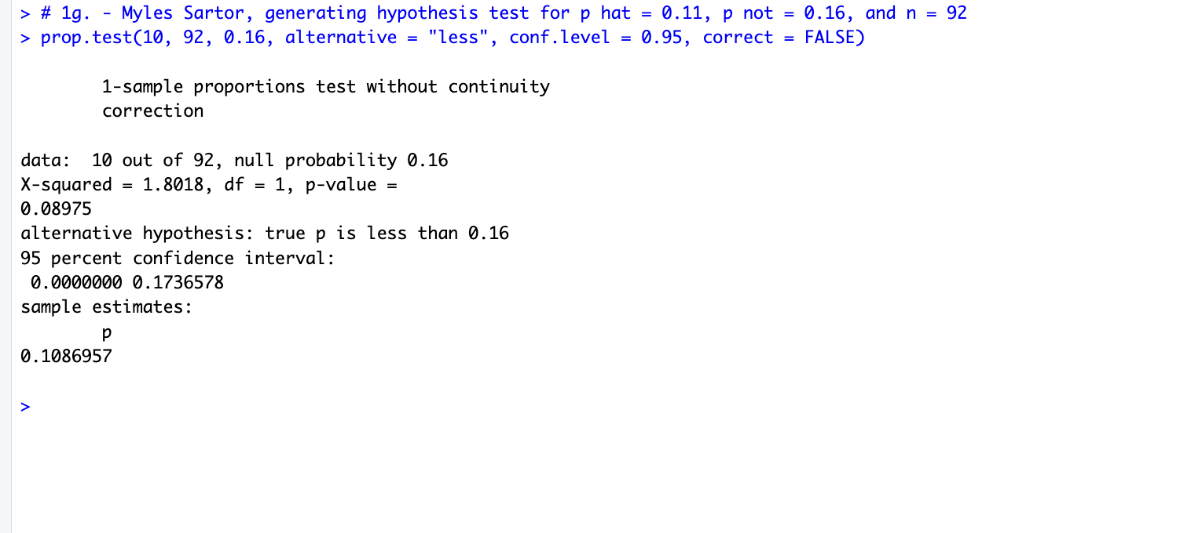
2a. 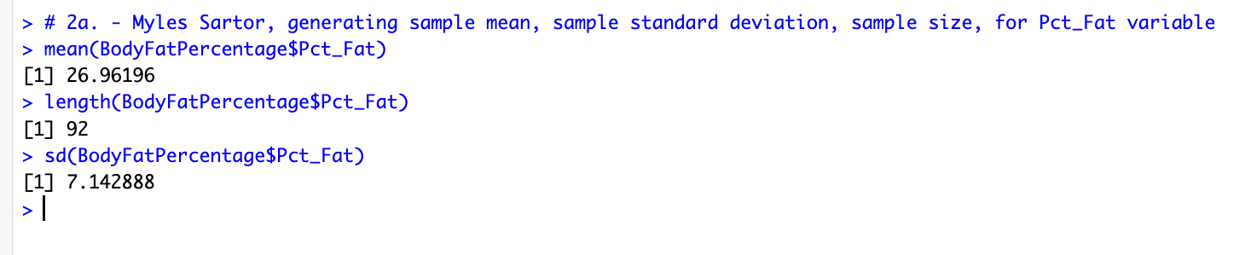
2b.
Null hypothesis: H₀ : µ = 25.5
Alternate hypothesis: H₁ : µ > 25.5
2c. n > 30
n = 92
92 > 30, meaning the conditions have been met
2d.
t = x – µ / ((s / sqrt(n))
t = 26.96 – 25.5 / (7.14 / (sqrt(92)) = 1.96
Test statistic: 1.96
2e. 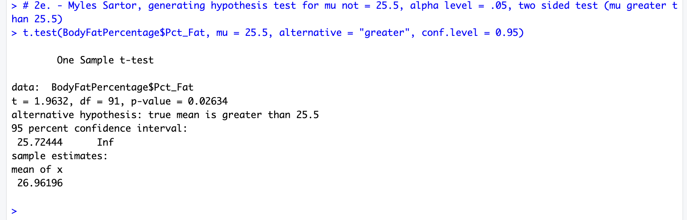
2f.
P-value: 0.9750
2g. Since the p-value 0.9750 is greater than the level of significance 0.05, we will fail to reject the null hypothesis, meaning that the mean body fat percentage for all adolescent girls is equal to 25.5 (Not accepting the alternative hypothesis).
2h. If this were a two-tailed test, then the p-value would be 0.05 according to the z-table and formula. I found this by using the previous 1.96 test statistic, and finding the value to be 0.9750, which I subtract from the number one to get 0.025. Then, I multiplied this number by 2 so could get 0.05.
P(Z ≤ -|z0|) + P(Z ≥ |z0|) is the formula for a two-sided p-value, which can also be found by multiplying by 2 when subtracting the original p-value from.

